1.Simple interest calculation.
import java.util.*;
public class simpleinterset {
public static void main(String[] args) {
int p,y,roi;
char c;
System.out.println("enter the price amount ");
Scanner s=new Scanner(System.in);
p=s.nextInt();
System.out.println("enter no of yaers ");
y=s.nextInt();
System.out.println("are u senior citizien (s/n) ");
c=s.next().charAt(0);
if(c=='s'||c=='N'){
roi=p*y*12/100;
System.out.println("the rate of interset = "+roi);
} else if (c=='n'||c=='N') {
roi=p*y*10/100;
System.out.println("the rate of interset = "+roi);
}
else {
System.out.println("invalid input");
}

output.
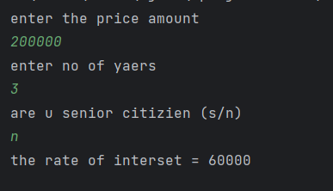

2. celsius to Fahrenheit.

import java.util.*;
public class celsiustofahrenheit {
public static void main(String[] args) {
int c,f;
Scanner s=new Scanner(System.in);
System.out.println("enter degerre in celsius ");
c=s.nextInt();
f=c*9/5+32;
System.out.println("fahrenheit = "+f);
}
}

output.
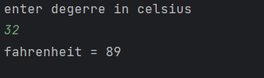

3.addtion of 2 no’s.

import java.util.*;
public class addofnos {
public static void main(String[] args) {
int a,b,c;
Scanner s=new Scanner(System.in);
System.out.println("enter no 1 ");
a=s.nextInt();
System.out.println("enter no 2 ");
b=s.nextInt();
c=a+b;
System.out.println("sum = "+c);
}
}

output.
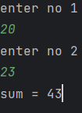

4.odd or even.
import java.util.*;
public class oddoreven {
public static void main(String[] args) {
int a;
System.out.println("enter a number ");
Scanner s= new Scanner(System.in);
a=s.nextInt();
if(a%2==0){
System.out.println("even number");
}
else{
System.out.println("odd number");
}
}
}

output.
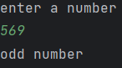

5.leap year not not.

import java.util.*;
public class leapyear {
public static void main(String[] args) {
int year;
System.out.println("enter a year ");
Scanner s= new Scanner(System.in);
year=s.nextInt();
if((year%4==0) && ((year%400==0) || (year%100!= 0))){
System.out.println("leap year");
}
else{
System.out.println("not a leap yaer");
}
}
}

output.
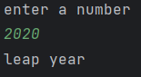

6.voting.
import java.util.*;
public class voting {
public static void main(String[] args) {
int age;
System.out.println("enter a age ");
Scanner s= new Scanner(System.in);
age=s.nextInt();
if(age>=18){
System.out.println("you can vote");
}
else{
System.out.println("you cannot vote");
}
}
}

output.
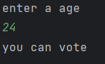

7.positive or negative

import java.util.*;
public class postornega {
public static void main(String[] args) {
int n;
System.out.println("enter a number ");
Scanner s= new Scanner(System.in);
n=s.nextInt();
if(n>0){
System.out.println("postive");
}
else if(n==0){
System.out.println("neither odd nor even");
}
else{
System.out.println("negative");
}
}
}

output.
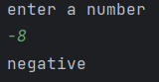

9.printing a string.

import java.util.*;
public class printingstring {
public static void main(String[] args) {
String a;
Scanner s=new Scanner(System.in);
System.out.println("enter a string ");
a=s.nextLine();
System.out.println(a);
}
}

output.

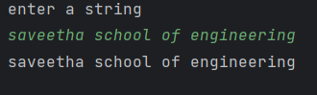

10.sum of series.

import java.util.*;
public class sumofseries {
public static void main(String[] args) {
int a,sum=0, i;
System.out.println("enter number ");
Scanner s = new Scanner(System.in);
a = s.nextInt();
for (i = 1; i <= a; i++) {
sum+=i;
}
System.out.println(sum);
}
}

output.

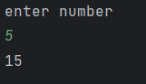

11.factorial.
import java.util.*;
public class fact {
public static void main(String[] args) {
int a, fact = 1, i;
System.out.println("enter number ");
Scanner s = new Scanner(System.in);
a = s.nextInt();
for (i = 1; i <= a; i++) {
fact = fact * i;
}
System.out.println(fact);
}
}

output.
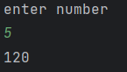
12.fibonacci.

import java.util.*;
public class fibo {
public static void main(String[] args) {
int a,f1=0,f2=1,f3,i;
System.out.println("enter number ");
Scanner s=new Scanner(System.in);
a=s.nextInt();
System.out.println(f1);
System.out.println (f2) ;
for (i=0;i<a;i++){
f3=f1+f2 ;
f1=f2 ;
f2=f3 ;
System.out.println (f3);}
}}
output.
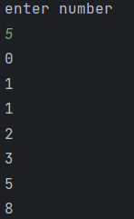

13.Armstrong.
import java.util.Scanner;
public class armstrong {
public static void main(String[] args) {
System.out.println("enter a number : ");
Scanner num = new Scanner(System.in);
int number = num.nextInt();
int n=number;
int res=0,temp;
while(n!=0){
temp=n%10;
res+=temp*temp*temp;
n=n/10;
}
if (res == number)
System.out.println("Armstorng number ");
else
System.out.println("Not armstorng number ");
}
}

output.
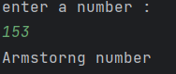

14(a).reverse integer.
import java.util.Scanner;
public class reverse_int {
public static void main(String[] args) {
System.out.println("enter a number : ");
Scanner num = new Scanner(System.in);
int n = num.nextInt();
int rev=0,temp;
while(n!=0){
temp=n%10;
rev=rev*10+temp;
n=n/10;
}
System.out.println("reverse = "+rev);
}
}

output.
